Contents

Introduction to ProModel’s Model Collaborator 1

Model Collaborator Environment 3

Toolbars 3

Model Selection Toolbar 3

Path Network Toolbar 4

Navigation Buttons 4

Getting Started in Model Collaborator 5

Tools Ribbon 5

Collaboration Project Steps 6

Step One: Selecting a Project 6

Step Two: Model Selection 7

Step Three: Collaboration Mapping 8

Step Four: Mapping Elements 9

Synchronizing Elements 10

Synchronization Commands 11

Don’t Synchronize 13

Path Networks 15

Step Five: Saving and Opening 18

Save Only 19

Save and Open 19

Model Layout and Graphics 19

# Introduction to ProModel’s Model Collaborator

Model Collaborator is an add-in to ProModel and MedModel. It enables a team of model builders to work on separate sections or models of a larger scale simulation model and then bring them together for simulation and validation. It allows an individual model builder to incorporate saved or pre-built modules into a new or existing model. The independent models or modules retain their individuality so that continued model building can occur over the course of a simulation project and thus allow teams to progressively collaborate on the overall model.

Model Collaborator has a wizard-like interface that steps you through the process of selecting, mapping, and combining multiple models, which then performs a type of advanced model merge before simulating the models together. It allows the user to specify which elements of each model should be unique and which should be shared with the other models being combined. The result of the collaboration is a new model, separate from each of the source individual models brought together.

A Model Collaborator project file is saved which stores the details of the collaboration and element mappings so that the process can be repeated even after the individual models being combined have been changed.

To perform a collaboration, the user first selects each of the models that are to be combined. Model Collaborator then scans each model and presents a list of the elements they have in common. The user then chooses which of the common model elements to map. Model Collaborator takes them through for a more detailed mapping or synchronization of shared items in each model element to create the new model.

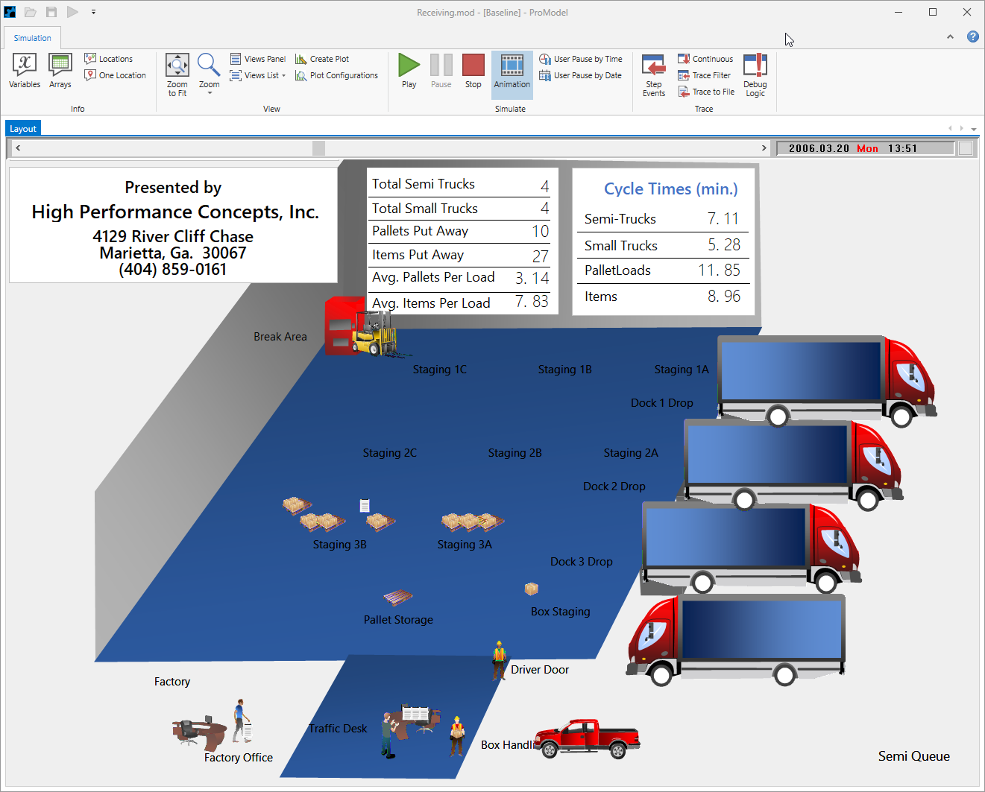

Once the detailed mapping is complete, a combined model is automatically built. This resulting model contains all elements of each of the source individual models, including only one instance of each of the shared or mapped items.

Model Collaborator can be accessed from the Tools ribbon within the application.

## Model Collaborator Environment

Navigating Model Collaborator is very simple and allows the user to move forward or backward, if necessary, through the collaboration process in a wizard-like fashion. Model elements can be mapped and synchronized in as little as three screens after the models are selected. Toolbars and navigation buttons aid the user in this process.

## Toolbars

Two primary toolbars are used in Model Collaborator, the **Model Selection** toolbar and the **Path Network** toolbar.

### Model Selection Toolbar

Allows users to add or delete models, clear the list of models, or designate one of the models as the base model.

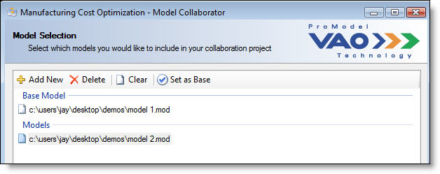

**Add New** Opens a browse dialog for selecting a model or base model to include in the collaboration project.

**Delete** Removes the selected model file(s) from the list.

**Clear** Removes all the model files in the list.

**Set as Base** Sets the selected model file as the Base Model. The previously designated Base Model will be moved into the Models group.

### Path Network Toolbar

Allows users to define path segments for connecting mapped networks together, delete added segments, or clear the list of added segments.

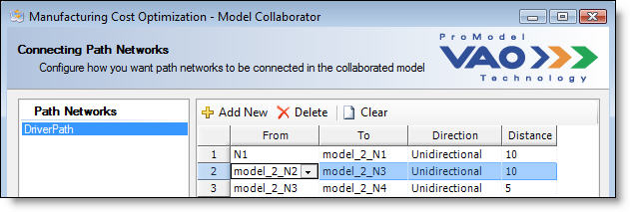

## Navigation Buttons

Located at the bottom of the Model Collaborator window, allows users to easily move from screen to screen through the Model Collaborator process.



**Reset**  Clears all of the user-selected choices in the project and resets the wizard to the initial Model Collaborator screen.

**Back** Steps back to the previous screen in the Model Collaborator wizard.

**Next** Steps forward to the next screen in the Model Collaborator wizard.

**Save and Open** Saves the collaboration project (.pmsp) file, builds the collaborated model, and then opens the resulting model in ProModel.

**Close** Exits the Model Collaborator application.

# Getting Started in Model Collaborator

To start a new Model Collaborator project, open Model Collaborator by selecting it in the **Tools** ribbon tab.

### Tools Ribbon

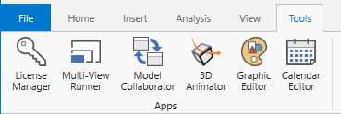

# Collaboration Project Steps

## Step One: Selecting a Project

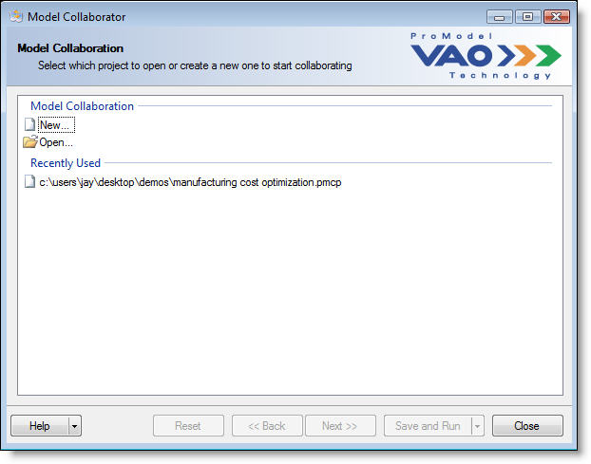

1. Select **New** or **Open**.
   1. If you select **New**, you will be asked where you would like to save your collaboration project (.pmcp) file.
   2. If you select **Open**, a browse dialog will open allowing you to search for an existing collaboration project (.pmcp) file.
2. Or choose from the **Recently Used** list. This list will appear automatically below the **New** and **Open** folders once you have been working in Model Collaborator and save one or more collaboration projects.

## Step Two: Model Selection

Select the models you will use for your collaboration project. The first model you select will be listed under **Base Model**. The second and additional models you add to your collaboration project will be listed under **Models**. This is shown below.

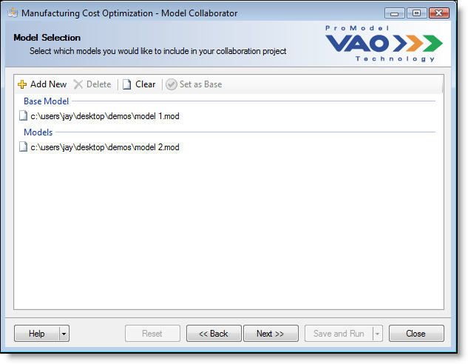

The model designated as the base model serves as the model from which the other models will be compared. However, the base model can be later changed by selecting another model in the list and clicking the **Set as Base** button in the Model toolbar.

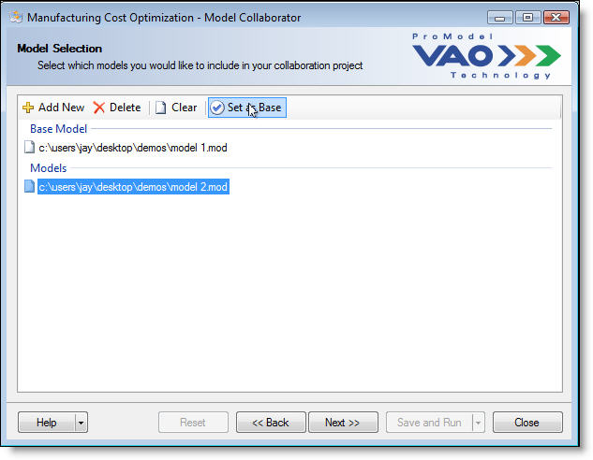

Select **Next** from the navigation buttons at the bottom of the screen.

## Step Three: Collaboration Mapping

This takes you to the **Collaboration Mapping** screen and triggers Model Collaborator to scan each model and determine its common elements. Only the elements that the models have in common will be listed once the scan is complete. The list of possible common elements includes: arrays, attributes, entities, macros, path networks, resources, subroutines, and variables.

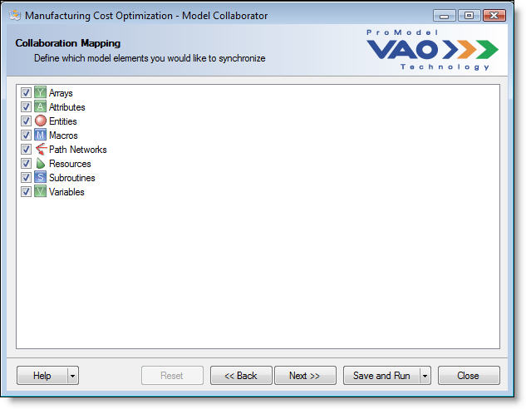

Choose the model elements that you would like to define item by item mappings for by checking the box next to the element(s).

Select **Next** to begin the mapping process one model element type at a time. If the mappings have already been defined previously, selecting **Save and Open**, will skip the subsequent mapping steps and build and open the resulting model in ProModel.

Note: by selecting **Back** at this point**,** you will reset all mappings unless they have previously been saved in a collaboration project file. A dialog will warn you of this when you select the **Back** button.

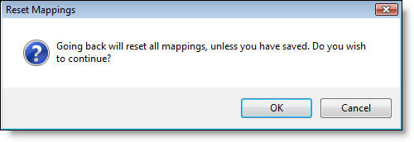

## Step Four: Mapping Elements

After you have selected which model elements you want to synchronize in the **Collaboration Mapping** screen, Model Collaborator steps you through those element types and allows you to configure how each item should be mapped. Each element type will have its own mapping screen that has a table containing every item of that element from all models in the project. See the screen shot below.

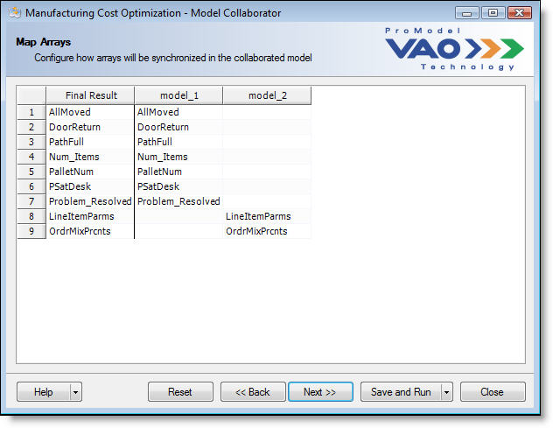

The first column in the table is the **Final Result** column. It is a read only column that shows what each mapped item will be named in the resulting model. The second column contains all the items found in the base model. Columns three and higher will list the element items found in the other models defined in the project.

Model Collaborator automatically organizes element items in the rows of the table based upon the item names. Items with the same name between two or more models are listed on the same row, which signifies that they are mapped and will be synchronized as one item in the resulting model.

Because the base model doesn’t get changed, the cells within that column cannot be selected. The columns listing the elements of the other models, however, do have a drop down menu for synchronization options.

### Synchronizing Elements

Synchronization of individual element items occurs when they are listed in the same row, regardless of whether or not they have the same name.

In the **Entities** screen below, two entity element items are listed in the same row. They are “Truck” and “Labels”. Model Collaborator automatically detected, during the model scan process, that **model_1** and **model_2** have two entities with the same names, “Truck” and “Label”, and placed them in the same row.

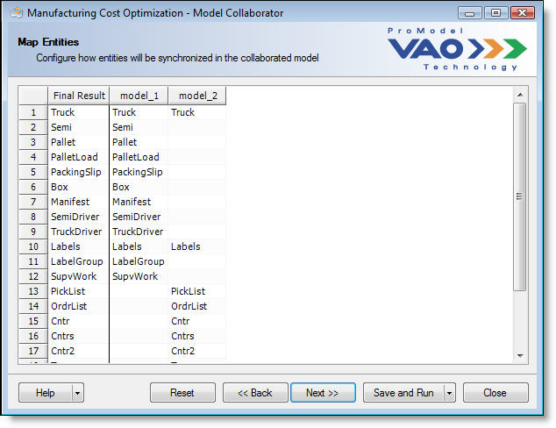

If you know that these items are common between the models, and want them to be synchronized, then no further action is necessary.

To proceed to the next list of elements, select **Next**.

For information on how to choose what elements of your model you would like to synchronize, please see, “Synchronization Commands”.

### Synchronization Commands

Because Model Collaborator can synchronize and combine any number of models, it is possible that an element item that is meant to be common between models could have a different name in each model. For example, let’s look at the **Map** **Resources** table below.

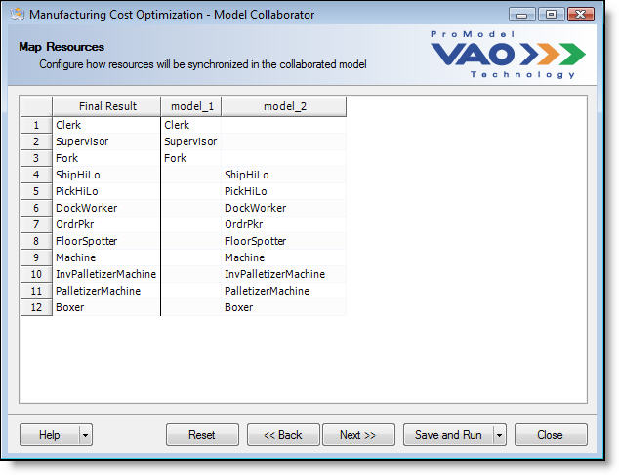

When Model Collaborator scanned **model_1** and **model_2**, it did not find any resources with the same name. Therefore, none of the resources are listed in the same row. However, because you are familiar with the two models, you know that the “Fork” resource in **model_1** is the same resource as “Machine” in **model_2**, and you would like to map these two resources so they are synchronized to be shared in the resulting model.

To synchronize, follow these steps.

1. Click in the cell on the third row in the **model_2** column.

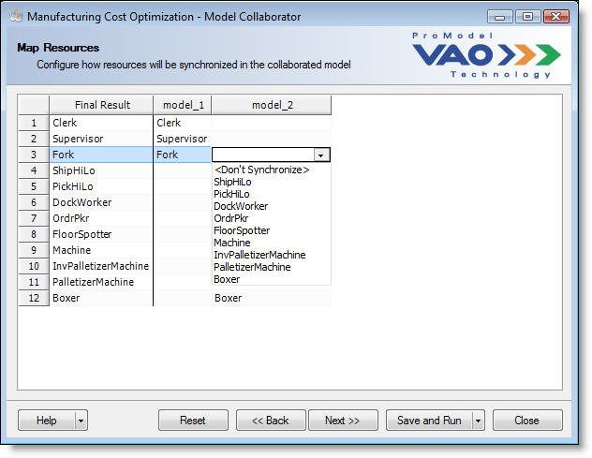

1. Scroll through the list of resources under the drop down and select “Machine”.

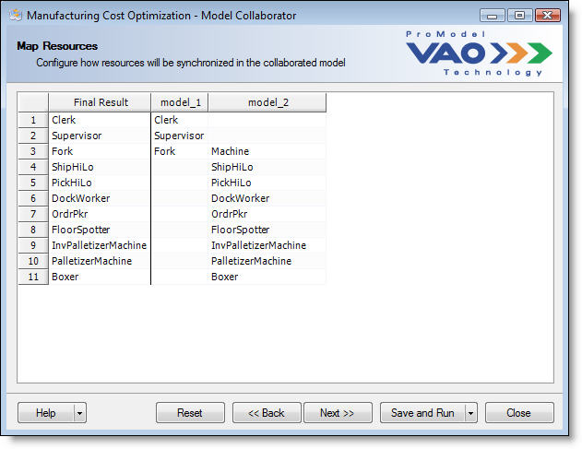

Note: Notice how the resource “Machine” now populates row three in the **model_2** column and is no longer on row nine. “Fork” and “Machine” are now mapped.

1. With the resources “Fork” and “Machine” in the same row, they will be synchronized in the resulting model when you **Save and Open**.
2. Repeat these steps for other resources that should be mapped.

### Don’t Synchronize

When Model Collaborator scans your models, it lists element items with the same name in the same row of the table. However, even though items may share the same names, it doesn’t necessarily mean that they should be synchronized and shared in the resulting model.

For example, in the screen shot of the **Map** **Entities** table below, for two comparative models, we see the names of each model’s entities in the columns, **model_1** and **model_2**. For both models, two entities with the same name exist, “Truck” and “Labels”.



Let’s assume that although the names of these entities are the same, they are not similar in properties or functionality between the two models, so we do not want to synchronize them for the resulting model. In order to unmap or separate these two entities and make them unique, follow these steps:

1. Click on “Truck” in the **model_2** column and a dropdown arrow will appear.
2. In the dropdown list, select <**Don’t Synchronize>**.

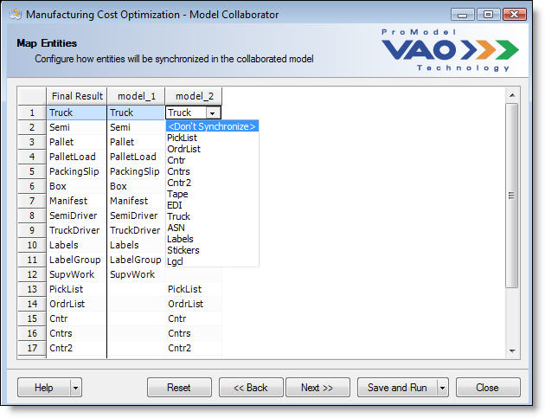

Notice how “Truck” in the **model_2** column was removed and a new row was created immediately below it. The “Truck” entities in each model are now separate and will not be synchronized in the resulting model.

Also notice that the resulting entity name shown in the **Final Result** column is called, “Trucks_model_2”. Because Model Collaborator has found that there are two entities with the same name listed in different rows, it must uniquely identify one of them. It does this by taking the original entity name and appending, as a suffix, the model name to which the entity belongs.

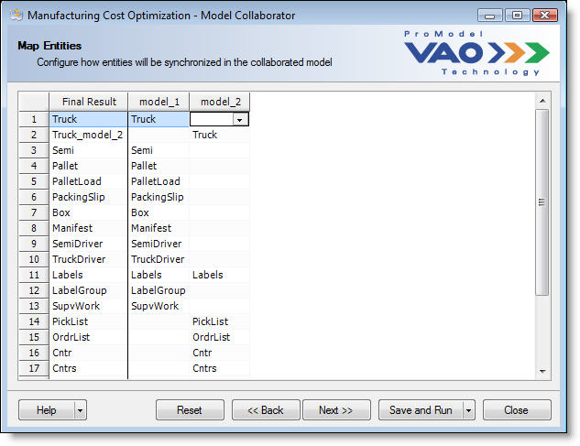

### Path Networks

The mapping of Path Network elements in Model Collaborator is a little different than the mapping of other model elements. First, it is unique because Time- and Speed & Distance-based networks must be mapped separately. Second, if two or more path networks are synchronized in the resulting model, there must be at least one segment created to connect the paths so that resources can travel anywhere on the resulting network.

Below is an example of a collaboration project that synchronizes Speed & Distance-based networks.

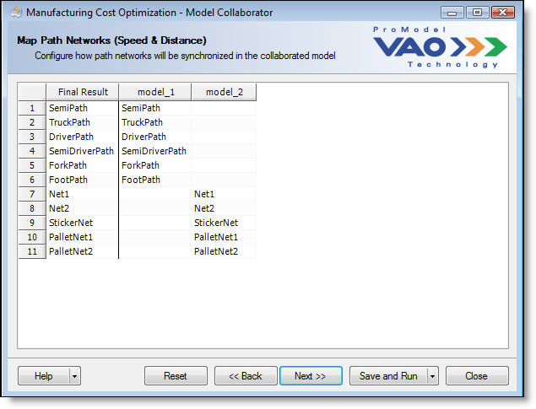

Notice how **(Speed & Distance)** is in parentheses of the **Map Path Networks** title. If the path network in your models was based on time then the word **(Time)** would be in parentheses.

Based on the **Map Path Networks** screen above, the models do not share a path network with the same name. To map two networks, follow these steps:

1. Click on the cell for row three in the model_2 column.
2. From the dropdown list, choose network “Net1”. Notice in the screen shot below that Net1 has been mapped to the “DriverPath” network on row three and removed from row seven. Other networks can be similarly mapped as desired.

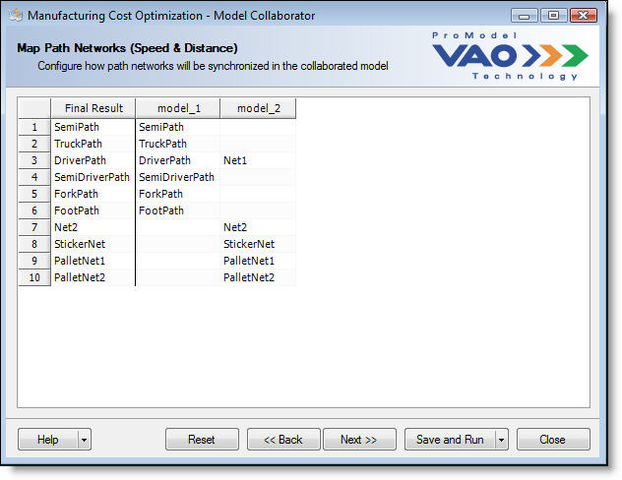

1. Select **Next >>**.



1. This takes you to the **Connecting Path Networks** screen. Select your path network from the **Path Networks** list on the left.

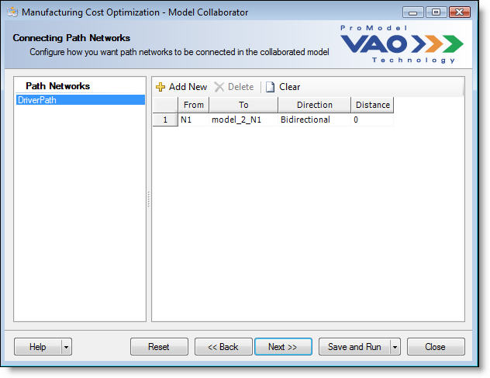

1. In the path segment details table on the right, a segment is automatically created which connects the first node in the **model_1** network to the first node in the **model_2** network.
2. The created segment can be modified or additional segments can be added to this network that will be combined in the resulting model.
   1. To edit an existing segment:
      1. Highlight one of the path segments in the table on the right by clicking on its row.
      2. Select the node from where the segment will begin by clicking on the cell in the **From** column and opening the dropdown list.

Note: All nodes from each network will be listed. Nodes from the base model will have their original names. Nodes from the other models will be given a prefix based upon their model name.

* + 1. Select the node that you want the path to end on by clicking on the cell in the **To** column and opening the dropdown list.
    2. Select the Direction you want the segment to orient, by selecting either “Bidirectional” or “Unidirectional”.
    3. Enter the Distance (or Time, if time-based) for this segment.
  1. To add a new segment:
     1. Click the **Add New** button from the toolbar.
     2. A default segment is appended to the table. Edit the details as described in the step above.

Your resulting network, after adding segments, should look similar to the screen shot below.

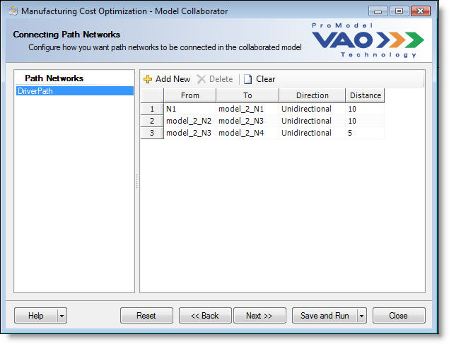

## Step Five: Saving and Opening

By stepping through each mapping element in Model Collaborator, you will eventually come to a screen that looks like this:

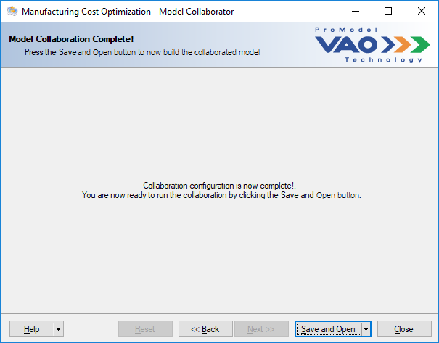

The **Save and Open** button in the navigation button section is a multi-function button. It not only acts like a button, it also acts as a dropdown menu. It is like having two buttons in one. When the dropdown arrow on the button is clicked, the user is given two choices:

* **Save Only**
* **Save and Open**

These two options initiate the final steps of model collaboration.

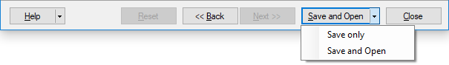

### Save Only

Selecting **Save Only** saves your defined mappings or changes to the collaboration project (.pmsp) file. A message informs you of the path and filename where the model has been saved on your computer.

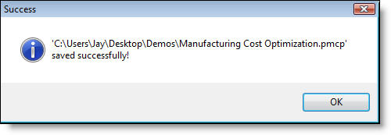

### Save and Open

Selecting **Save and Open** saves any changes to the collaboration project (.pmsp) file, builds the resulting collaborated model, and then opens it in ProModel.

### Model Layout and Graphics

Model Collaborator automatically places the other models in the collaboration project to the right of the base model in the layout. Currently, there is no way to specify another position in the layout for each combined model.

All simulation options and other model properties are taken from the base model. For example, the scale of the base model will set the size to which the other models will be drawn when built into the resulting model. Also, if the base model is set to run by calendar date, the resulting built model will run by calendar regardless of the other models’ settings.